

**MIDDLE EAST TECHNICAL UNIVERSITY**

ELECTRICAL & ELECTRONICS ENGINEERING

*EE463 – STATIC POWER CONVERSION 1*

*TERM PROJECT – COMPLETE SIMULATION REPORT*

Emin ÜN 2167476

Enes CANBOLAT 2231546

Berkay UZUN 2263812

TABLE OF CONTENTS

1.INTRODUCTION 2

2.TOPOLOGY SELECTION 2

3.CIRCUIT ANALYSIS & SIMULATION RESULTS 3

3.1 Diode Rectifier and Buck Converter Block 3

3.2 Current Sense and Amplifier Block 5

3.3 DC Voltage Generator Block 6

3.4 Error Amplifier Block 7

3.5 PI Controller Block 8

3.6 PWM Generator Block 9

4. THE PERFORMANCE OF THE CIRCUIT BASED ON THE VARIATION OF INPUT TORQUE 11

5.COMPONENT SELECTION 13

5.1Mosfet Selection 13

5.2 Diode Selection 13

5.3 Capacitor Selection 14

5.4 Inductor Selection 15

5.5 Resistor Selection 15

5.6 Op-Amp Selection 16

6.CONCLUSION 0

# 1.INTRODUCTION

Renewable energy is defined as useful energy collected from renewable resources. The wind is one of the renewable resources. It is used to provide mechanical power to the wind turbines to generate electricity. Wind power is widely used in sustainable energy. However, there are some problems with using the electricity produced in wind turbines. These turbines, generally, behave like an electric generator with a continuously varying output voltage and output current. In this project, Kardeşler Elektronik A.Ş. introduces AC to the DC Converter project which regulates the output current. In the first part of this report, the topology of the converter will be discussed. The advantages and disadvantages of different topologies will be compared. Moreover, the reason for the topology selection will be given. In the second part, the circuit schematic and its simulation results with ideal cases will be provided. Moreover, the component selection and cost analysis will be provided in the second part. To conclude, our engineering skills in circuit design, simulations, and our project management skills will improve. Additionally, this project will give us an opportunity to implement the theoretical knowledge of us on EE463 lecture.

# 2.TOPOLOGY SELECTION

As mentioned in the 'Introduction' section, the generated voltage needs to be rectified to feed the given battery. To do this rectification, there are some topologies that can be used. Using a 3-phase thyristor rectifier and the diode rectifier with a buck converter are the most common ones. In this project, we preferred the diode rectifier with a buck converter topology because of some reasons. Firstly, controlled the thyristors considering their phase difference is not an easy job; however, the diode rectifier does not need any gate voltage and operates without any external intervention. On the other hand, we need to control the gate voltage of the MOSFET and hence the duty cycle of the buck converter to keep the output current the same. For this operation, again there is no one solution, using integrated circuits (IC) is one of the alternative solutions; however, the operating conditions are very important for these ICs. As shown in the 'Simulation Results' section, the input voltage varies, and this high voltage can damage the selected IC. That's why we preferred to control the gate signal of the MOSFET with an analog circuit design. Moreover, we wanted to observe the feedback operation step by step. If we used an integrated circuit, we would not be able to observe the entire circuit. Due to missing IC models in MATLAB and the modeling problem of input generator and battery in other simulation applications, we wouldn't be able to examine the performance of the design. Because of the pandemic conditions, we have also no chance to physically work on the designed circuit in the laboratory. Considering all these reasons, we decided to design an analog PI controller circuit. The last thing, we need to feed the gate of the MOSFET and hence we used one of the most common PWM generators called 555timer which can also be modeled in MATLAB Simulink. In short, we chose diode rectifiers with a buck converter topology and designed a closed-loop PI feedback controller without using any integrated circuit. In the following section, circuit blocks will be examined in detail and the simulation results will be shown.

# 3.CIRCUIT ANALYSIS & SIMULATION RESULTS

As mentioned before, our circuit design includes some parts and in this section, these blocks are examined in detail. In Figure 1, the block diagram of the circuit design is visualized.

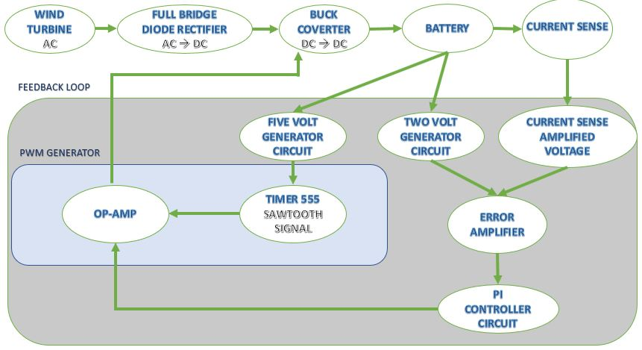

Figure 1 Block Diagram of the Circuit Design

## 3.1 Diode Rectifier and Buck Converter Block

As we learned in our lectures, a 3-phase diode rectifier is a good method to rectify the given AC signal; however, it is not enough to feed the battery without any external component since the output of the rectifier depends on the input voltage and it is affected by the changes in the input voltages. In the following Figure 2, the input voltage waveforms of the rectifier are illustrated.

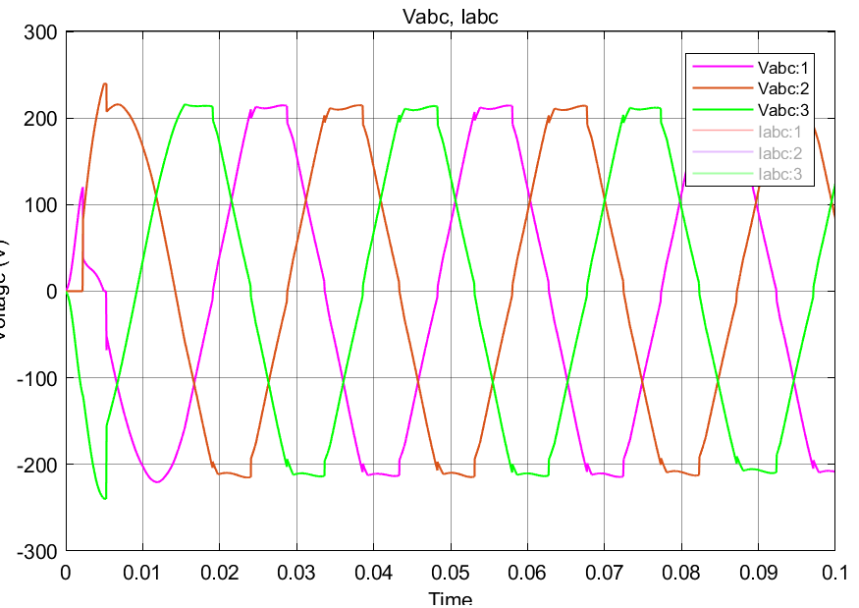

Figure 2 Input Voltage Waveforms of Diode Rectifier

The output voltage waveform is not a pure DC signal, in other words, the voltage ripple is very high on this waveform. Therefore, we used a shunt capacitor (100µF) to filter this signal. Then, we connected this output to the MOSFET of the buck converter. For the buck converter design 15mH inductor and 100µF capacitor are used. In the following Figure 3, this block of the design is shown, also in the next figure the input currents of the diodes are shown. These current values are important while selecting the proper diode.

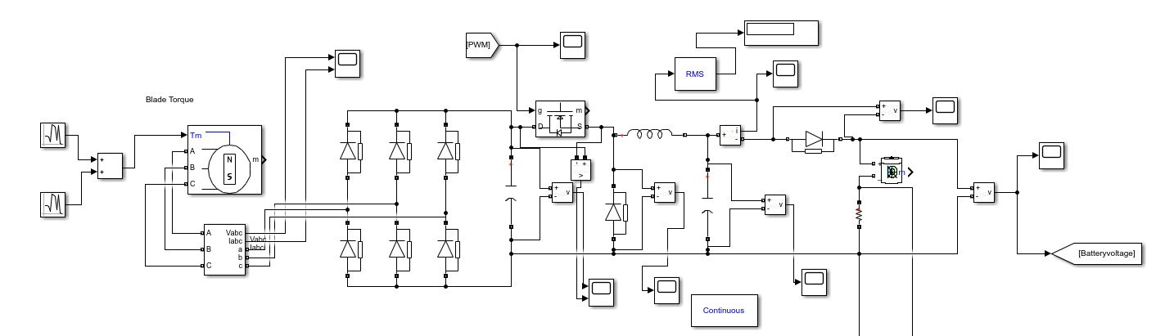

Figure 3 Diode Rectifier and Buck Converter Block

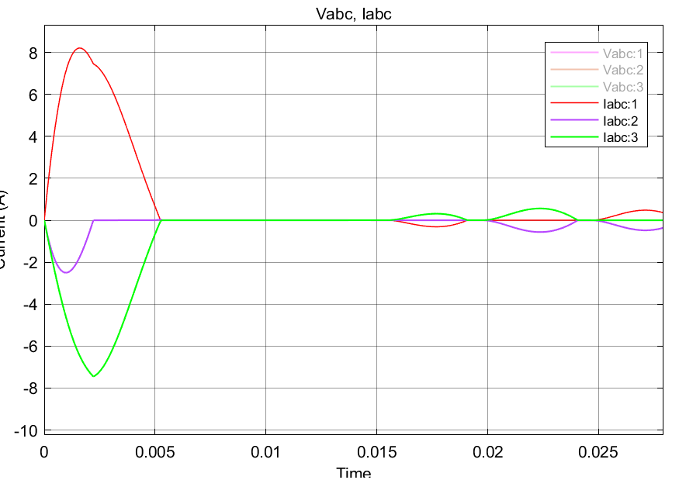

Figure 4 Input Current Waveforms of Diodes

## 3.2 Current Sense and Amplifier Block

In the project description, the input current value of the battery is given as a constant 2A and the ripple limit is 20% of the average current which is also specified in this description. Not to exceed this limit we connected a small resistor (250mΩ) to the negative leg of the battery. By checking the voltage on this resistor, we can understand the current flow through the resistor and hence the battery and using this knowledge we can start our feedback loop; however, the resistance and current values are not high enough to decide the error. Therefore, we amplified this voltage value up to 3V and this block and this amplified voltage are shown in Figure 5 and Figure 6, respectively.

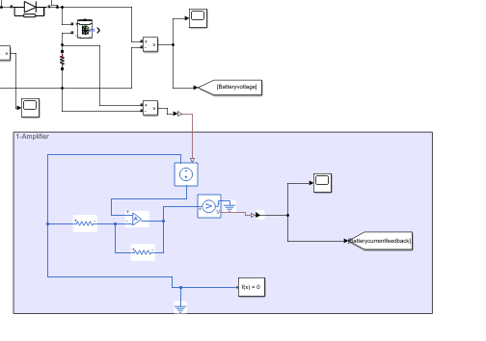

Figure 5 Current Sense and Amplifier Block

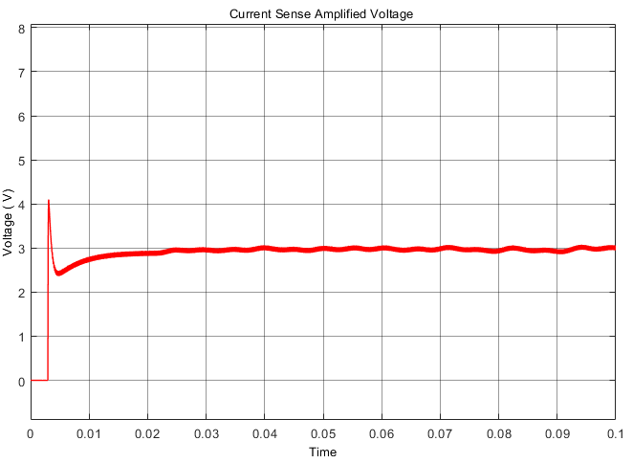

Figure 6 Waveform of Current Sense Amplified Voltage

## 3.3 DC Voltage Generator Block

In this design, we need to use DC voltages in some parts of the circuit such as feeding op-amps, the input of error amplifier, and input of 555timer component. Instead of using an external DC supply voltage, we use the battery input voltage. In the following Figure 7, the circuit schematic of this voltage generation block is shown. Note that, in this design, we need 2 and 5V values and their circuit schematic consist of two inverting amplifiers with different resistive values. In Figure 8 both 2V and 5V blocks' output values are shown.

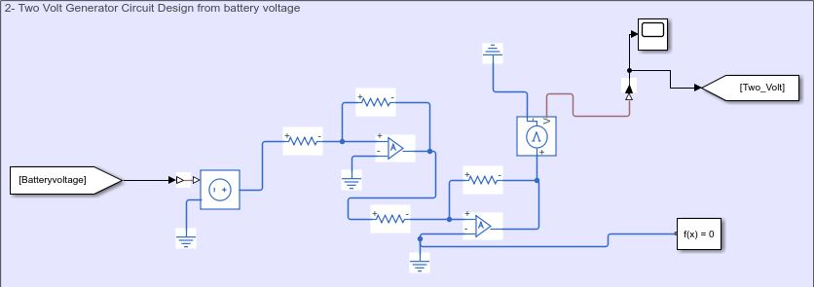

Figure 7 2 & 5V DC Generator Block

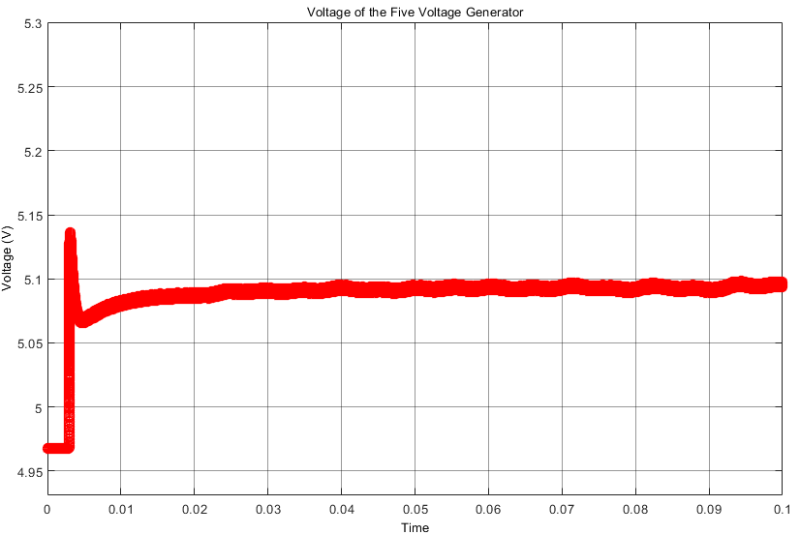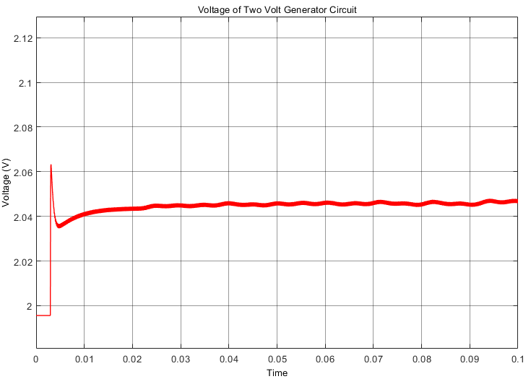

Figure 8 Output waveforms of 2- & 5-Volt Generation

## 3.4 Error Amplifier Block

In this part of the design, we found the error voltage using a differentiator circuit design. Using the 2 Volt DC and amplified current sense values, the difference between the (V+ & V-) input voltages of the op-amp is given as the output of this differentiator. Then, using this knowledge we can arrange the duty cycle of the buck converter. The positive error means that the current is lower than 2A and the duty cycle needs to be increased and if the negative error is observed, this time the current passing through the battery is higher than 2A and the duty cycle needs to be decreased in order to decrease the current value. The error amplifier block and the error signal can be shown in the following Figures 9 & 10, respectively.

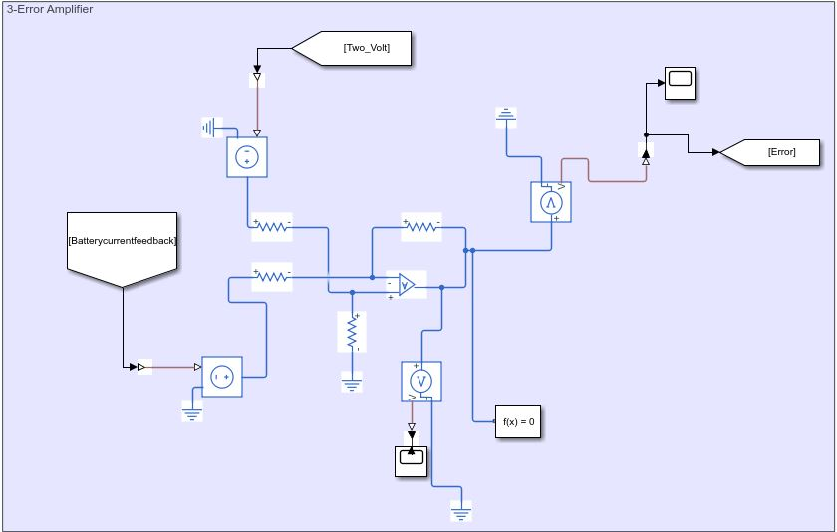

Figure 9 Error Amplifier Block

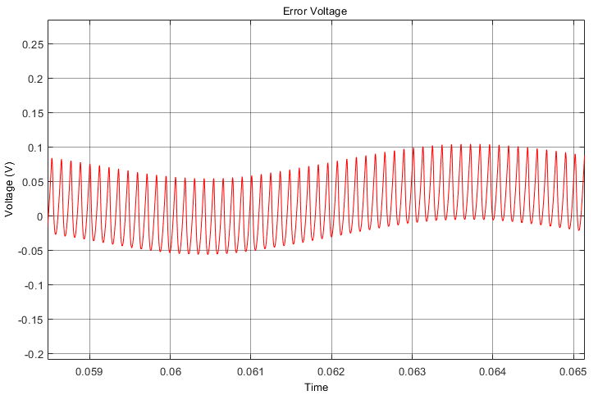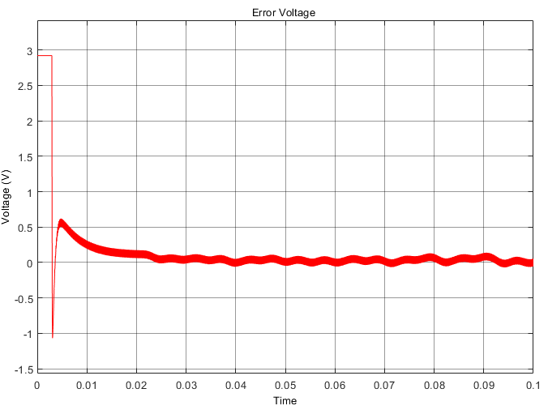

Figure 10 Error Voltage Waveform Before the Steady-State (Left Side) & Zoomed Version in the Steady-State (Right Side)

## 3.5 PI Controller Block

The aim of this block is to control the battery current using the error voltage which is explained in the previous section. As known, the transfer function of PI Controller is $H\left(S\right)=K_{p}+\frac{K_{i}}{s}$, and to create this transfer function we used 3 sub-circuits that are proportional, integrator, and summer. If it is necessary to explain briefly, the proportional part amplifies the error voltage and the ratio of two resistors in this part is the important parameter. The integrator block takes the integral of error voltage and multiplication of resistor and capacitor values are the important parameter for this block. Finally, the summer block sums these two values. The following Figure 11 shows the PI Controller block and the output waveform of this block can be seen in Figure 12.

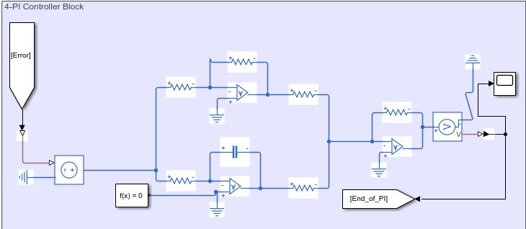

Figure 11 PI Controller Block

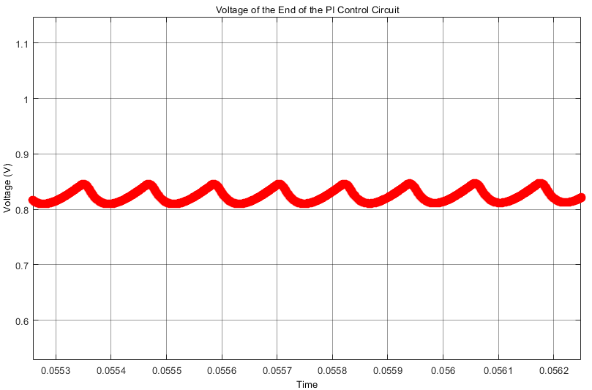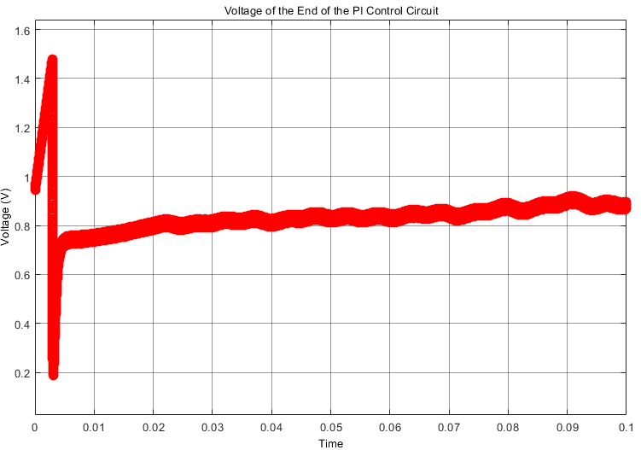

Figure 12 Output Voltage Waveform of the PI Controller Block (Zoomed Version is Shown in the Right Side)

## 3.6 PWM Generator Block

The last step of the feedback loop is generating the pulse voltage considering the output voltage of the PI Controller block. In this part, we used a common component called 555Timer and this creates the sawtooth signal. In order to activate this 555Timer device, we feed it with 5V which is mentioned in the previous sections of the report. Then using an op-amp, we can compare the output of the PI Controller, and this generated sawtooth voltage. After this comparison operation, the output is a form of a square wave, in other words, pulsating voltage waveform with changing duty cycle depending on the battery current. Both op-amp and Timer555 components create the PWM Generator block which is shown in the following Figure 13. Moreover, the output of this PWM generator can be seen in Figure 14. Note that, this voltage is directly connected with the gate of the MOSFET of the buck converter.

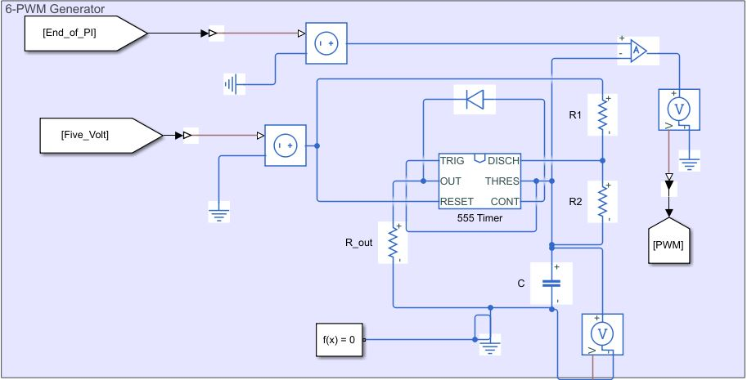

Figure 13 PWM Generator Block

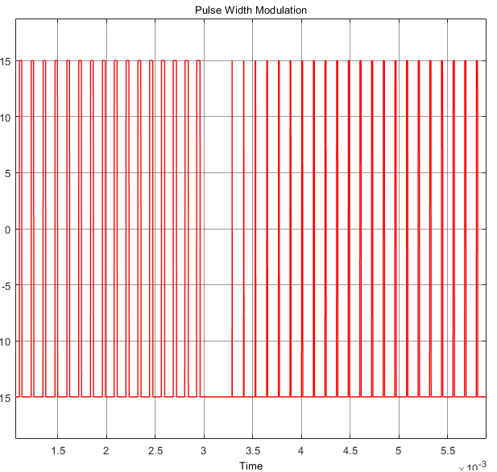

Figure 14 Input of the MOSFET's Gate

According to our simulation results in the previous report, at the end of this feedback loop, we were able to get an average of 2.013 A current through the battery. The ripple on this current was about 5% of the average current. In other words, it changed between 1.96 and 2.06A. In addition, when the circuit first started working, the current suddenly increased to 5 A for a very short time. Thereupon, we reduced this peak current to around 2.75 A by changing the resistors and capacitance in the PI controller circuit. After making these changes, at the end of this feedback loop, we can achieve an average of 2A current through the battery. The peak to peak ripple on this current is about 5% of the average current. In other words, it changes between 1.95 and 2.05A in the following Figure 15, this battery current can be seen.

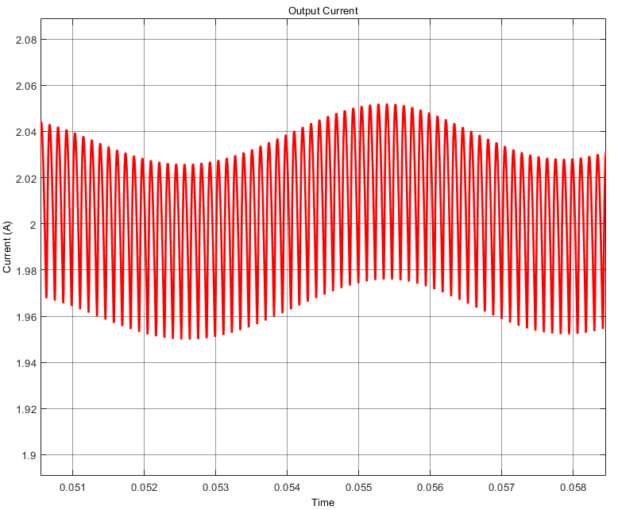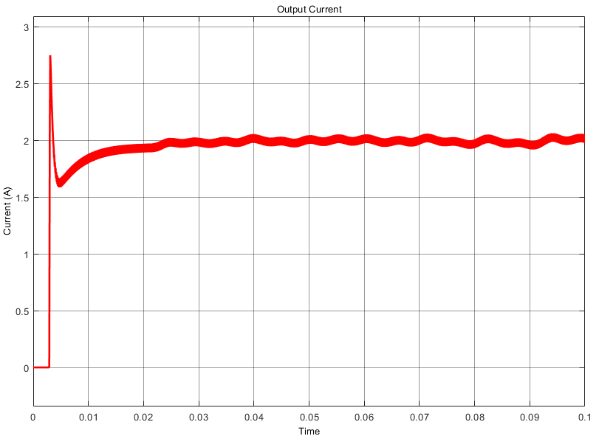

Figure 15 Waveform of the Output Current (Zoomed Version is Shown in the Right Side)

# 4. THE PERFORMANCE OF THE CIRCUIT BASED ON THE VARIATION OF INPUT TORQUE

As it is known, our input voltage is AC and we obtain this AC voltage from the wind turbine. Our input voltage can change with the torque generated by the wind turbines. In this part, we gave different voltages to the circuit by changing the input torque. We determined the performance of our system with these different input voltages.

In Figure 16, we increased our input torque as much as possible. As can be seen from the figure below, the input voltage has converged to 800 V.

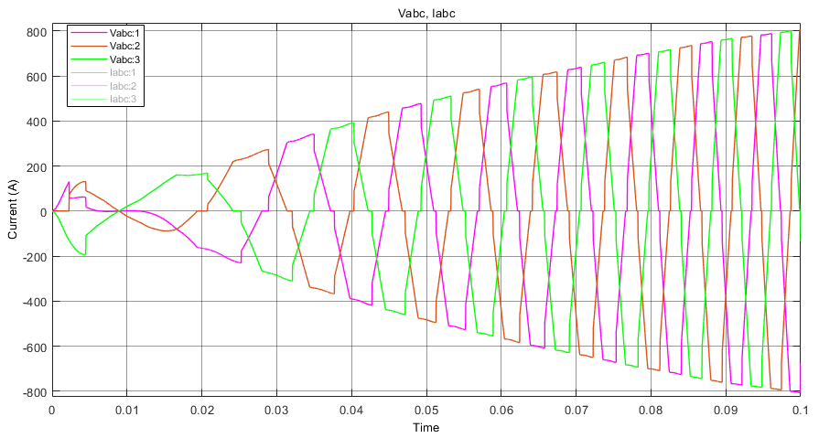

In Figure 16, we can see the current flowing through the battery. As can be seen from the figure below, when our input voltage is 800 V, our circuit also provides a current of around 2A to the battery.

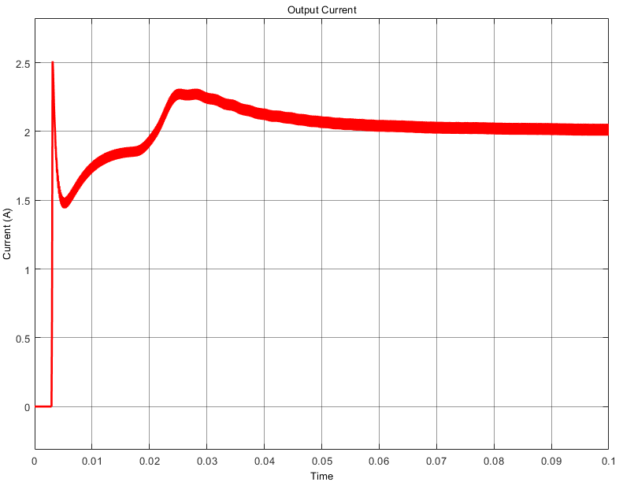

In Figure 18, we decreased our input torque. As can be seen from the figure below, the input voltage has converged to 190 V

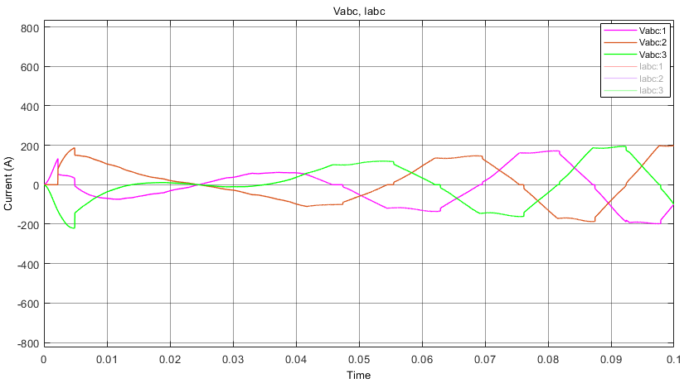

In Figure 19, we can see the current flowing through the battery. As can be seen from the figure below, when our input voltage is 190V, our circuit also provides a current of around 2A to the battery.

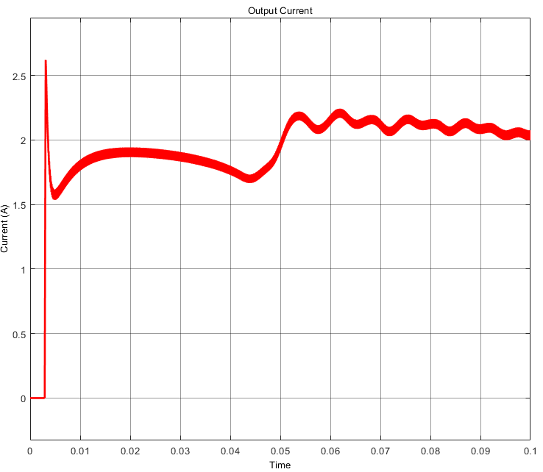

As can be seen from the graphics above, our circuit that we designed provides an average of 2A to the battery even though we change the input torque. In other words, 2A passes through the battery. As a result, we can say that the circuit we designed works between 190-800 V

# 5.COMPONENT SELECTION

There are many issues to be considered while selecting parameters. The parameters we choose may vary depending on the area we will use. In addition, since the parameter values ​​of the component, we will select will vary, these parameters should also be considered. Each component has its parameters that we can consider the most important. When choosing components for our system, we have made the selection by evaluating the component types suitable for the area we will use based on parameters. We decided the parameter values ​​according to the simulation results we got from the circuit we designed.

## 5.1Mosfet Selection

When choosing MOSFET, we made a selection by considering the maximum and rated values of voltage and current ​​of our system. At first, we did not consider the warming phenomenon when choosing the MOSFET. The MOSFET we chose did not have any function for self-cooling. In other words, we couldn't install any heatsink to dissipate the heat on the MOSFET. Later, to eliminate this problem, we chose one of the TO-220 packaged MOSFETs. In this way, we will be able to dissipate the heat on the MOSFET by attaching the heatsink. In addition, when choosing MOSFET, we paid attention to the small $R_{ds}$ value. In addition to these, what we expect from the selected MOSFET is that it meets the following values. However, these values ​​may increase depending on the change of input torque. That's why we kept the voltage range of our MOSFET more than the following values ​​for safety. Considering these values, we chose N-Type MOSFET.

Table 1 shows the maximum and rated values of voltage and current of our system.

Table 1 Maximum and Rated Values of Voltage and Current of our system

|  |  |  |
| --- | --- | --- |
|  | Rated Value | Max Value |
| Voltage (V) | 210 | 240 |
| Current (A) | 2 | 5 |

## 5.2 Diode Selection

While choosing the diode, we determined the maximum voltage values ​​of the diode I would choose by calculating the voltage of the diode in the circuit. We have diodes in 3 different places. The diodes we chose were selected to be used in the rectifier circuit, buck converter circuit, and before the battery. There are diodes specially designed for rectifier circuits. We made our choice by looking at the voltage rating. We calculated the voltage values ​​of the diodes in the other two places with the help of Simulink and made the selection in that way. The diodes we selected are Schottky diodes.

Figure 16 shows the voltage waveforms of diodes at the buck converter and before the battery respectively. The diode before the battery is used as a safety diode.

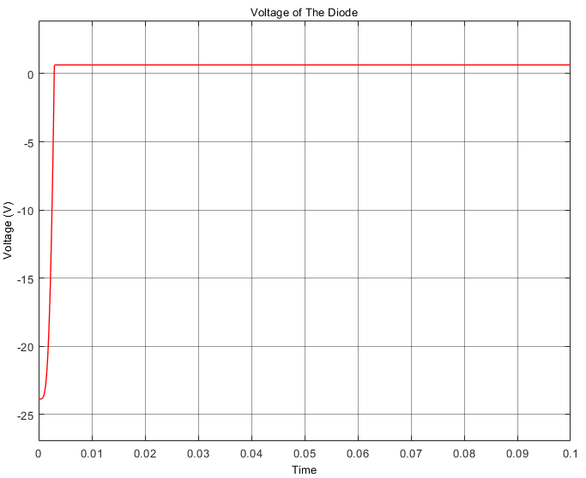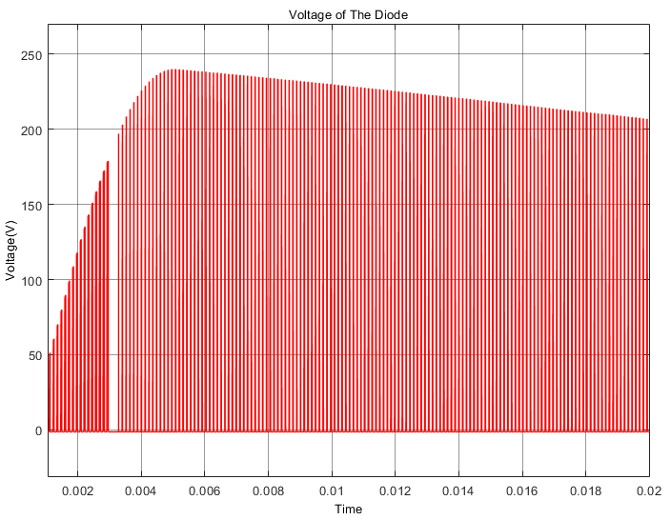

Figure 16 Voltage Waveforms of Diodes at the Buck Converter and Before the Battery Respectively

## 5.3 Capacitor Selection

While choosing capacitors, we calculated the voltage between capacitor terminals in the same way. Also, one of the other things to consider when choosing a capacitor is the size of the capacitor and its ripple factor. In addition to these, it is the endurance to current and voltage on the capacitor. Considering these, we made a capacitor selection. The capacitors we have selected are cheaper than others, the ripple factor is better. Also, their endurance performance is good enough and they have low ESR.

Figure 17 shows the voltage waveforms of the capacitors in our circuit. These capacitors were used at the output for filtering, a buck converter circuit, and TIMER 555 circuit for generating sawtooth signal respectively.

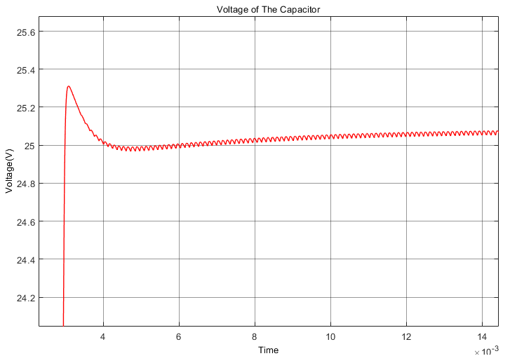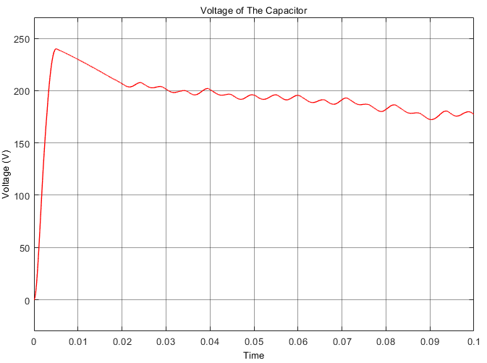

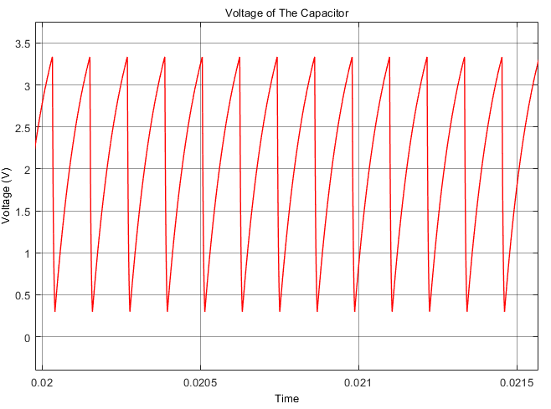

Figure 17 Voltage Waveforms of the Capacitors at Output, Buck Converter Circuit, and TIMER 555 Circuit Respectively.

## 5.4 Inductor Selection

While choosing the inductor, we made a selection considering the current flowing through it and the voltage value of the system. We also tried to choose a low cost of the inductor.

Figure 18 shows the current through the inductor. As can be seen from the graph, at first it takes a close order of 5A, but then it flows stably around 2A.

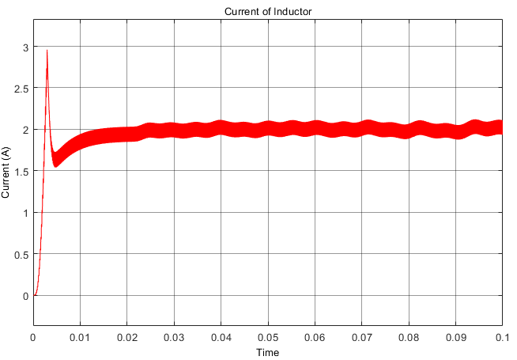

Figure 18 Current Waveform of the Inductor at the Buck Converter Circuit

## 5.5 Resistor Selection

One of the things we paid attention to when choosing a resistor was the material. Since the number of resistors in our circuit is high, we chose resistors made of a material with a low weight.

## 5.6 Op-Amp Selection

There are op-amps in 2 different regions in our circuit. One is in the main circuit; the others are in the feedback loop. While choosing op-amps in these places, we took into account the voltage values ​​there. Our voltage value in the main circuit is too much compared to other places. For this reason, we have chosen an op-amp that has a higher endurance compared to the op-amps in the feedback loop.

According to these important points of view, Table 2 shows the component selection list with the cost analysis.

# 6.CONCLUSION

In this project, we aimed to regulate the output current of a wind turbine to charge a battery with constant voltage and constant current. In this report, the project and its processes are explained. First of all, topology selection is explained. After that, the circuit is analyzed, and its simulation results are provided with the components that are selected for the project. The cost analysis is provided for the component selection.

Starting with this early stage of the project, we have improved our engineering skills on circuit design and simulation and management skills with the cost analysis of the project. In conclusion, by implementing this project, we have improved our skills to use the theoretical knowledge from the EE463 course.